ENROLLMENT
Celebration begins Sunday, July 16, 2017 from 2–4 pm Celebration ends July 22, 2017 12:00 noon.
Name:________________________________________
Name:________________________________________
Street:________________________________________ City: _________________ State: ______ Zip:_______
Home #: _______________Cell #: _________________
Email:________________________________________
Roommate Preference: _____________________________________________
Linens: Linens and pillows are not provided at Saints Grove Campground.

Enrollment Fees Include Lodging and Meals For The Week: “With Early Bird Incentive”
Enrollment Received Before May 15: $55/Person, $135/Family Max*; Enrollment Received Before June 15: $75/Person, $210/Family Max*; Enrollment Received After June 15: $90/Person, $300/Family Max*
Number per Family (Age 3 And Over): (1) _____ (Infants 2 and Under Are Free)
Total Fee: (line 1 x Amount $55, $75, or $90)
(2) $ _________

Note: *Family Maximum Applies To All IndividualsLiving At The Same Residence)

Part-time Fees: Daily fee for part-time, including meals is $15 per day/per person. If you are staying over-night the fee is $18 per night/per person. If you will be attending part-time, please “x” the day or days below:
___ Sunday __ Monday __ Tuesday ___ Wednesday __ Thursday __ Friday
___Saturday

Total Fee: Number of people - age 3 & over x $15 or $18 = $ _________

Please include check or money order (USD) payable to “CCM” with this enrollment form and mail to: Linda Stephen, 1137 Seiler Street, Alton, Illinois, 62002. Cell (314) 662-3662 (stephenld@charter.net)

CCM MINISTRIES

Contemporary Christian Ministries (CCM) is a ministry of Community of Christ.
- Open style of worship that is relaxed and informal, full of joy, praise, and spirit-filled.
- Uses contemporary Christian music.
- Incorporates people’s giftedness into worship services.
- Inter-generational participation.

OUR MISSION
MINISTRIES

“We bring Christ's healing love and compassion
to hungry, thirsty, broken, and lost lives.”
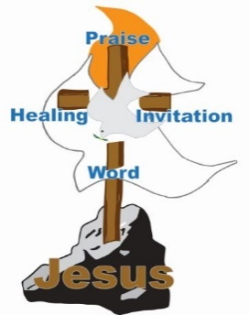
“We feel a call to develop disciples of Jesus Christ who can take the good news of the gospel to the “bruised and broken-hearted” and those who are enmeshed in sin to offer the love, hope, peace and joy that can be found only in Jesus Christ.”

“We proclaim Jesus Christ and promote
communities of joy, hope, love and peace.”

Evangelist Request:
Interested in Ministry from an Evangelist, e.g., Prayer, Counsel, or Blessing –
Please note your request below:
___________________________________
____________________________________________________________________________________________________________________________________________

CHRIST’S MISSION, OUR MISSION
CONTEMPORARY CHRISTIAN
2017 CCM CELEBRATION

July 16-22, 2017
Saints Grove Campground
Glencoe, OK

“Let It Be Love”

For more information about
2017 CCM Celebration go to:

www.bymyspirit.us/cel17
www.facebook.com/CCMLT

PROGRAMS
Ministry
- Preaching Nightly
- Healing Service
- Music Ministry
- Communion
- Intercessory Prayer

Education
- Adult/Youth Classes
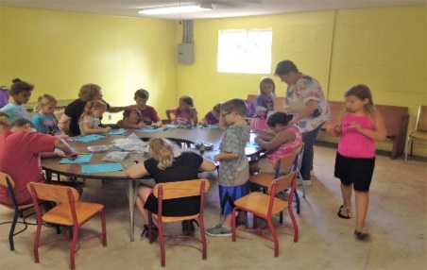

Community
- Swimming

- Fishing and Fun
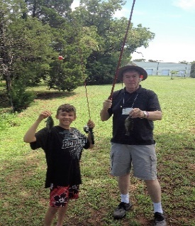
WEEKLY THEME

“Let It Be Love”

SUNDAY | What Is Love?
MONDAY | What Does Love Look Like?
TUESDAY | What Does Love Feel Like?
WEDNESDAY | What Does Love Sound Like?
THURSDAY | What Does Love Smell Like?
FRIDAY | What Does Love Taste Like?
SATURDAY | What Is Love?

Baptisms
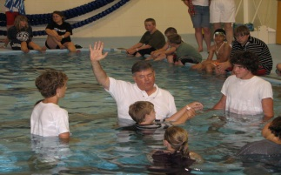

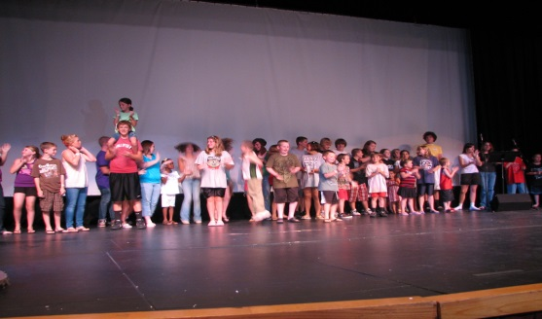
Youth Activities

GUEST MINISTRY

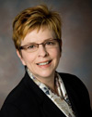
Karin F. Peter is President of the Fifth Quorum of Seventy and North Central USA Mission Field Special Support in Greater Pacific Northwest USA Mission Center.

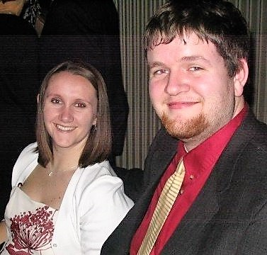
Jacob and Rachel Blakesley are in the Alabama Northwest Florida Mission Center. Jacob is a middle school Exceptional Student Education teacher focused on the worth of all persons in his mission as a Seventy. Rachel is the Assistant Director of Residence Life at the University of West Florida and a High Priest and Pastor at the North Pensacola Community of Christ. They have worked in children and family ministry for the past fourteen years. Both are passionate about sharing God's Love with everyone, providing servant ministry, and welcoming all into the blessings of community.

