2019 REGISTRATION
Sunday, July 7, 2019 at 2pm to July 13, 2019 at noon.
Name:________________________________________
Family Members: _____________________________________________
Street:________________________________________ City: _________________ State: ______ Zip:_______
Home #: _______________Cell #: _________________
Email:________________________________________
Roommate Preference: _____________________________________________

KIDS 0-18 ARE FREE!

THE LODGE:
Handicap & Medically Necessary ONLY
By May 31: $125/ Age 19+
June 1-30: $145/ Age 19+
After July 1: $150/ Age 19+

CABINS/ RV HOOKUPS:
By May 31: $95/ Age 19+
June 1-30: $105/ Age 19+
After July 1: $110/ Age 19+

Number of adults per Family _________
Number of kids per Family _________

Total Fee Enclosed:
$ _________

Part-time Fees:
Daily (includes meals) $20 per day/per person.
Overnight $25 per night/per person.
If you plan on attending part-time, please “x” the days below:
__ Mon __ Tues __ Wed __ Thurs __ Fri

Fee: # people age 18+ x $20 or $25 times # of days
$ _________
Please include check or money order (USD) payable to “CCM” with this form and mail to: Shara Matlock sharamatlock@gmail.com
1204 Breezy Valley Dr (901) 612-1015
Cordova, TN 38018

OUR MISSION
Contemporary Christian Ministries (CCM) is a ministry of Community of Christ.
- Open style of worship that is relaxed, informal, full of joy, praise, and Spirit-filled.
- Incorporates Contemporary Christian music.
- Encourages the sharing of ALL people’s giftedness.
- Inter-generational focus.

“We bring Christ's healing love and compassion
to hungry, thirsty, broken, and lost lives.”
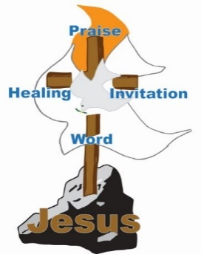
“We feel a call to develop disciples of Jesus Christ who can take the good news of the gospel to the “bruised and broken-hearted” and those who are enmeshed in sin- to offer the love, hope, peace and joy that can only be found in Jesus Christ.”

“We proclaim Jesus Christ and promote
communities of joy, hope, love and peace.”

Requests for Ministry:
Interested in Ministry from an Elder or Evangelist?
Prayer, Counsel, or Blessing?
Please note requests below:
______________________________________________________________________________________________________________________________________________________
_______________________________________

CONTEMPORARY CHRISTIAN
MINISTRIES

2019 CELEBRATION

July 7-13, 2019
Saints Grove Campground
Glencoe, OK

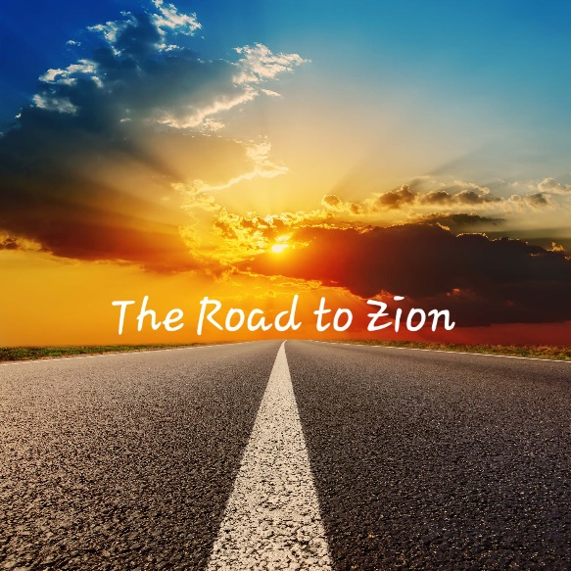
“Road To Zion”

Follow Us on Facebook:
https://www.facebook.com/CCMLT/

Register Online:
https://forms.gle/2y3CBLewVeTLk2hB9

Visit our Website:
ccm4you.com

CELEBRATION:
Transforming, Renewing &
Intergenerational

- Spirit- led Preaching
- Prayer for Healing
- Powerful Ministry
- Communion & Baptism
- Intercessory Prayer
- Adult/ Youth Education
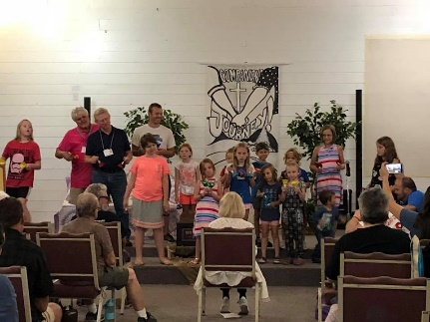

Community Focused

- Recreational
- Opportunities for service
- Shared Experience

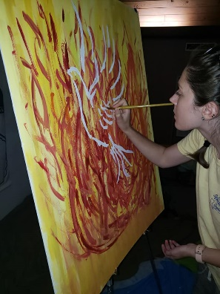

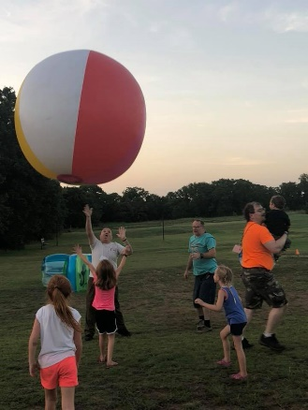

WEEKLY THEME

“Road To Zion”

SUNDAY | Fill Your Tank
MONDAY | Paved with RIDICULOUS Grace
TUESDAY | Missed Turns & Blessings In Disguise
WEDNESDAY | Stretch Your Legs & Comfort Zones
THURSDAY | Hitchhikers And Feeding Lost Sheep
FRIDAY | Your Destination is ALL AROUND
SATURDAY | Rested & Filled; Take ZION with you

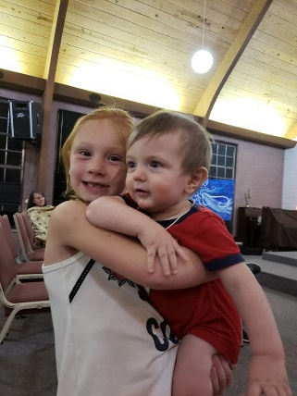

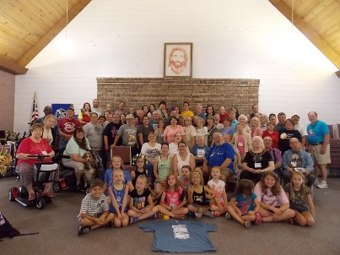

GUEST MINISTRY

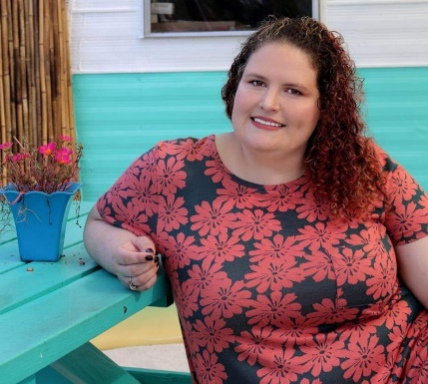
Molly Bagley
She grew up with her Dad’s testimony of what Zion means to him- a people of “one heart and one mind.” When she attended Seminary, she realized what a powerful effect that had had on her. Zion isn’t some place far in the future. Zion is what we create here and now. She looks forward to joining us on this road trip as we realize our roles in creating the kingdom of God NOW!

With Special Guest:
Kenny Alcorn
and YOU!
Celebration is full of opportunities for you to share with others! Please come prepared to share YOUR gifts, talents, and testimonies!

