‹
CCM 2020 CELEBRATION

Registration Starts Here!
Choose from (2) options

- Mail-in Registration
Send by landmail or Email. Fill out Form

- On-line Registration
Click on link to access GOOGLE FORMS link

PAYMENT INFORMATION

All payments will be by check or money order. No on-line payments.
Celebration Fees:
- YOUTH 18 AND UNDER
ATTEND FREE!!!!

- EARLY BIRD FEE DISCOUNTS AVAILABLE - REGISTER BY
May 31, 2020 *

Fees and Discount Dates
LODGE: | CABINS/ RV HOOKUPS:
By May 31: $125*  June 1 +: $150 | By May 31: $95*  June 1 +: $110
Part-Time Fees: (both includes meals)
Daily $20 per day/per person.
Overnight $25 per night/per person.

OUR MISSION

We are called to develop disciples of Jesus
Christ who can take the Good News of the Gospel to the “bruised and broken-hearted”.

We bring Christ's healing love and compassion to hungry, thirsty, broken, and lost lives. We offer the love, hope, peace and joy that can only be found in Jesus Christ.

We proclaim Jesus Christ and promote
communities of joy, hope, love and peace.

OUR WORSHIP STYLE

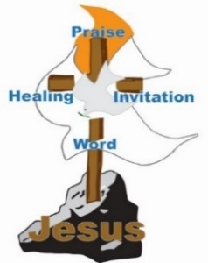
- Open style of worship that is relaxed, informal, full of joy, praise, and Spirit-filled.
- Incorporates Contemporary Christian music.
- Encourages the sharing of ALL people’s giftedness.
- Inter-generationally focused.

SHARE YOUR GIFTS
AND TALENTS

Come participate and share your testimonies and spiritual gifts. Bring your musical instruments
and favorite songs.

Make a joyful noise and sing for and with us. Please include your talents you want to contribute, on your registration form.
Celebration is full of opportunities for you to share with others.
Please Come !! !!!

CONTEMPORARY CHRISTIAN
MINISTRIES

2020 CELEBRATION

July 26 -August 1, 2020
Saints Grove Campground
Glencoe, OK
“Blessings of Zion”
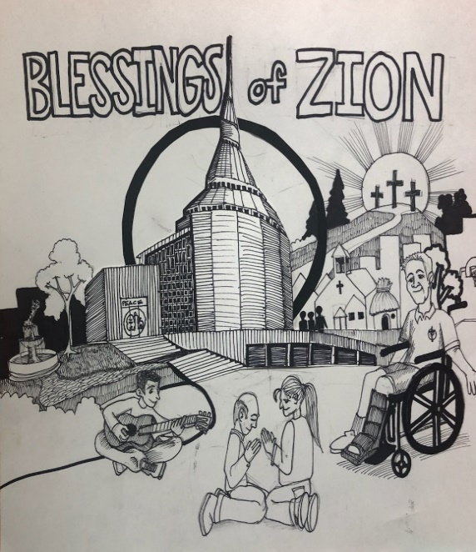
REGISTER NOW! See inside
Visit CELEBRATION 2020 information https://www.ccm4you.com/cel20info.html
Visit our CCM WEBSITE https://www.ccm4you.com

CELEBRATION

Transforming, Renewing and
Intergenerational
- Spirit- led Preaching
- Prayer for Healing
- Powerful Ministry
- Communion and Baptism
- Intercessory Prayer
- Adult/Youth Education

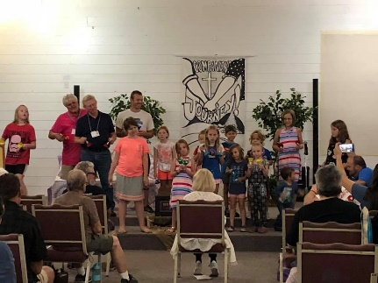

Community Focused

- Recreational
- Opportunities for Service
- Shared Experience

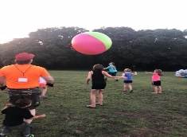

WEEKLY THEME

“Blessings of Zion”

SUNDAY | Divine Peace
MONDAY | Unity in the Community
TUESDAY | Knowledge, Wisdom, Revelation
WEDNESDAY | Stewardship and Accountability
THURSDAY | Grace And Generosity
FRIDAY | Worth of ALL Persons
SATURDAY | Divine Calling, Courage, and Challenge

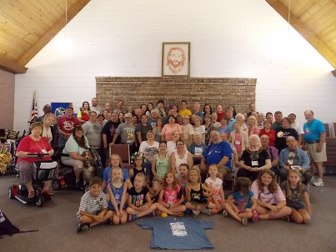

JULY 26 OPENING SESSIONS

2:00 PM Arrival - Registration Opens
4:15 PM Welcome & Introductions
5:30 PM Supper
7:30 PM Evening Worship

GUEST MINISTRY
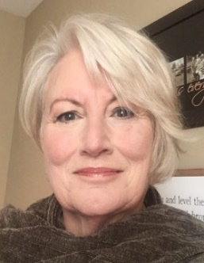
Seventy Judy Hubbard

Judy loves God, Jesus and the vision of Zion. She was blessed to grow up in Kirkwood, MO in a loving RLDS church family. She attended Graceland College, where she met her husband, Gene Hubbard. They married and had four beautiful, children, 13 grandchildren and two great grandchildren.

In 1998, God called Judy to come “learn of His ways” by starting a street ministry in Columbia Missouri’s Public Housing.

For 10 years she learned about the precious people, loved by God. She worked among and learned from those in poverty and suffering. Judy and Glenn Cobbins Sr. have been working together for 21 years, helping and loving people physically and spiritually to become inspired by the equality and worth of all persons to God and to one another.

For the next 15 years, the Imani Mission Center was sponsored by Community of Christ. The inner-city mission and Destiny of H.O.P.E. were blessed to feed the hungry, clothe the naked, visit the imprisoned, bring healing to the sick and addicted, and teach the people about God, Jesus and Zion!

Judy is anxious to come and share her testimony of God’s love and care for all persons.

